Exercise 4: Employee Management System
Array in Memory
- Arrays are stored in contiguous memory locations.
- Each element can be accessed directly using its index.
- The index starts from 0 and goes up to the size of the array minus 1.
Advantages of Arrays
- Fast access: Direct access to any element in constant time O(1).
- Simple structure: Easy to declare and use.
- Efficient for fixed-size data: Works well when the number of items is known.
Output
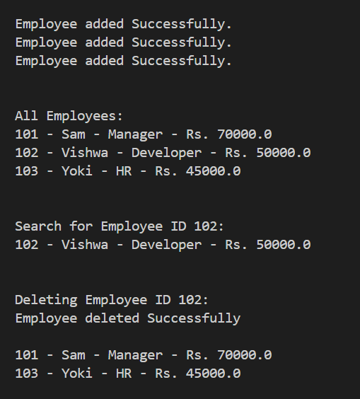
Time Complexity of Operations
- Add: Fast and takes constant time if space is available – O(1).
- Search: Takes time proportional to the number of employees – O(n).
- Traverse: Goes through each employee one by one – O(n).
- Delete: Slower because items need to be shifted after removal – O(n).
Limitations of Arrays
- Size is fixed and cannot grow once declared.
- Deleting an item requires shifting the rest, which takes time.
- Not suitable when adding or removing items frequently.
When to Use Arrays
- When the total number of items is small and known in advance.
- When you need quick access to elements by position.
- When a simple and memory-efficient structure is preferred.

